Video Group Clinics
Patient Frequently Asked Questions

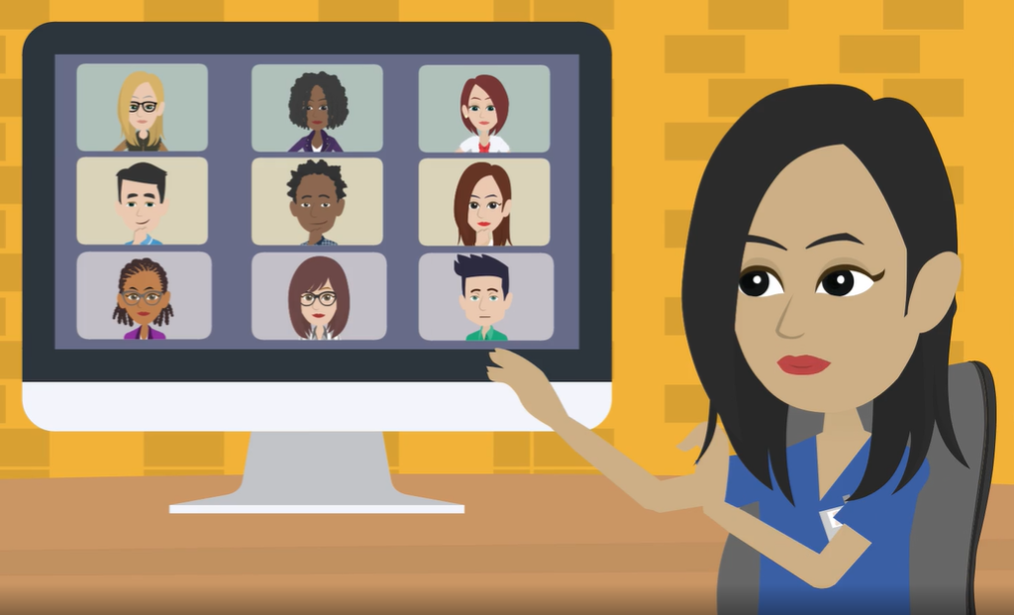

PATIENT FAQ

Q: What are video group clinics?

A: Video group clinics are a way for you to join people with similar health issues and consult with your GP or nurse for longer. You may also see consultants, pharmacists, social prescribers and health coaches in this way. They are also known as video group consultations or shared medical appointments. We are currently trialling this new method of offering you healthcare and welcome your feedback.

Q: How will I benefit from a video group clinics?

A: People who have participated in face to face group clinics say that they enjoy hearing from other people in a similar situation and having longer to talk about their worries. They say they enjoy sharing their concerns, what has worked for them and what doesn’t but also hearing from other people’s success. They report feeling a sense of belonging and that they are no longer alone in trying to manage their condition such as asthma, diabetes or depression.

This alternative delivery method is not just in response to COVID-19. We see it as a real alternative for some (not all!) that offers all involved key benefits.

Q: Can I still have a one to one video or face to face consultation with my GP or nurse?
A: Yes, practices will always offer face to face appointments and one to one appointments. Video group clinics are used as an extra way to support those who want to join in.

Q: How do I join a video group clinic?
A: You will need an email account or mobile phone with internet access and access to the internet in a private place. You don’t need any special programs as you will be sent a link to click on and access one of the suitable video platforms such as Microsoft Teams or Zoom.

Q: What happens in a video group clinic?

A: Once you’ve clicked the link to join in, you will be welcomed by a member of your GP practice team who will have been trained to be a facilitator. The facilitator will keep the group secure by asking you to confirm your identity and will start the session by reminding everyone in the group to keep information confidential.

They will then explain how the session will flow and each member of the group (often 8-10 participants) will introduce themselves. You will have time to review and understand the results you have agreed to share such as blood pressure, peak flow etc and come up with questions for your clinician who will join the group and have one to one consultations with each member. During this time people often join in and share ideas and problem-solve together. The facilitator will wrap up after 60-90 minutes and you might want to set goals for yourself.

Following the group you may want to make a one to one appointment to go through anything you didn’t want to share in the group situation or your clinician may want to arrange follow-up tests or referrals.

Q: How do I know a video group clinic is for me?
A: You can talk to your practice facilitator or to your own GP or nurse to find out more and check any concerns you might have. Group consultations might not suit everyone, if you are feeling anxious beforehand, let the facilitator know. It is OK to join a group just to listen and see if it is for you. Some people may even join in and decide to leave if it isn’t right for them. At any point you can leave a group and book a one to one appointment later.

Q: Can I have my yearly health check in a video group clinic?
A: Yes, many practices are offering the choice of having your yearly health check in a 90-minute group rather than a 10 minute appointment.

Q: What happens if I change my mind when I’m in a video group clinic?
A: If you feel a group clinic isn’t working for you, let the facilitator know and you can leave and book a one to one appointment later on. Feed-back will be collected after every clinic so let your facilitator know if you think things could be improved.

Q: Can patients form their own groups after a video group clinic?
A: Yes, some patients find that it is helpful to create support groups outside of the surgery to help each other stick to goals for example. Some practices might be able to support you to do this.

Q: Have video group clinics been tried before and what do patients think about them?
A: Yes, video group clinics have been used in America in The Cleveland Clinic and the University of California Department of Psychiatry for example and in Australia for many years. These teams report that patients find these just as helpful as face to face groups and health improvements have been seen. It is still early days for medical research to report on how successful video group clinics are in the UK which is why the University of Oxford is collecting feed-back from patients who have participated in a video group clinic.

Q: Why doesn’t my practice offer video group clinics?
A: Not all practices use video group clinics, this may be because they haven’t heard about them yet, don’t have the staff required or haven’t had the training that is being gradually rolled out. It may be because they don’t think video group clinics would be suitable for their practice patients. If you would like your practice to offer video group clinics you could bring this up in your practice patient participation group (PPG) or write to your practice manager.

Q: Do I need to have any blood tests or checks before I join a video group clinic?
A: Your facilitator will write to you before your video group clinic to let you know if you need any particular tests and ask for your permission to share this information in the session (you can of course refuse!). It is useful to bring with you any home recordings of weight, blood pressure and blood sugar readings for example.

Q: Can my partner, friend or carer join me in my video group clinic?
A: Yes, with your agreement. It is often very useful for carers or family members to join in. They will need to agree to confidentiality and confirm their identity just like other participants. Ideally you should keep to just one extra member or groups can get too large.
Video groups are particularly useful for this as a relative who lives at a different address or even abroad can join in to support you.

Q: Can I record my video group session?
A: No, to ensure all information shared in the session is kept confidential and your privacy respected, you will be asked to adhere to the ‘VGC Patient Agreement’. This asks you not to record, share or post any aspect of the session. It’s in everyone’s interest to respect this.

Q: Can I share my video group clinic link with someone else who wants to join in?
A: You should only share the link with a relative or carer that you wish to join you in the group clinic. You shouldn’t share the link with anyone else.

Q: What happens if I don’t want to say anything in a video group clinic?
A: Let your facilitator know if you are feeling worried about being in a group. It is OK to join a group to listen. Many people do this and end up joining in once they feel comfortable.

Q: What happens if I am late joining my group?
A: You may not be allowed to join the group as it is important that everyone has agreed at the start to confidentiality and confirms their identity. It also disrupts the group for others. You may be asked to book into another group clinic or one to one appointment.

Q: How is my health information kept confidential during a group?
A: All participants are requested to agree to a behavioural contract before they enter a group. This states that they agree not to share any information discussed within the group. Unlike the confidentiality regulations surrounding a doctor’s obligation to keep all information confidential, this is not enforceable by law. However, as a behavioural contract it is repeated throughout the group session and as all participants will be sharing personal information, it is thought that the chances of a confidentiality breach are low.

Your practice will ask your consent to share limited information about your condition that relates to the group topic. This information will be shared with the group in the form of a results board. For example, in a diabetes group this might include blood glucose levels, blood pressure and cholesterol.

Practices have been given training and support in confidentiality and information sharing. Platforms are in use which encrypt and meet the NHS cybersecurity quality requirements. NHS England and Information Commissioners Office advise behavioural contracts are in place to support this.

Q What will NHS England be doing to make sure that group consultations are being evaluated and improved as they spread throughout the UK?
A: An evaluation of the effectiveness of group consultation has been completed by Keele University ^{[ii]}. A research program with University of Oxford is evaluating Video Group Clinics. This project will be collating feedback from patients who participate in the first wave of GP practices who are setting up group clinics, these practices are known as the “VGC Sentinel Practices”.

Q: Is my personal information is stored on the computer after a video group clinic?
A: The type of information stored on remote consultation/video conferencing platforms differs from system to system. Information is stored before, during and after sessions and normally controlled via the privacy settings of the platform. Most platforms will provide information on privacy settings, the information they store and how to maintain confidentiality. Generally, you are advised to ‘Log Out’ of existing platform accounts and enter sessions as a ‘Guest’, to avoid sharing personal information like your full name and email.

Q: Are under 18s allowed to join or be in the background of a VGC and do they need to consent?
A: As with face to face consultations, young people below the age of 13 years must be accompanied by a parent or guardian. Young people between the ages of 13-15 years may attend alone if a clinician has assessed their competencies prior to the group but ideally, they should be advised to have a parent or guardian present.

If a young person is to be involved in the VGC they must be identified, consented and agree to adhere to the confidentiality/patient agreement as an adult would.

Young people (of any age) in the background of a VGC must be declared to the group and the facilitator must coordinate agreement within the group to progress. Facilitators/Clinicians must make the overall decision as to the appropriateness of the information being discussed with young people present.

Any other questions?
If you have other questions or if you have been to a group and want to add to this list of questions to help other patients please get in touch with your practice manager through your practice website. Thank you.

^{[i]} Gina B. Lasky and Maria T. Riva (2006). Confidentiality and Privileged Communication in Group Psychotherapy. International Journal of Group Psychotherapy: Vol. 56, No. 4, pp. 455-476.
^{[ii]}https://www.keele.ac.uk/media/keeleuniversity/ri/primarycare/GPN%20EBP%20CAT%20Group%20Consultations.pdf

